**Conditioning operating models for Atlantic bluefin tuna**

Tom Carruthers[1]

*SUMMARY*

We fitted a multi-stock spatial, seasonal operating model to preliminary data for Atlantic bluefin tuna to reveal data collection priorities and highlight the most critical areas for model development.

*KEYWORDS*

*Population modelling, spatial analysis, data collections, age composition, aerial surveys, catch statistics, fishery statistics, fishing effort, size composition, tagging*

# Introduction

A Management Strategy Evaluation (MSE, Butterworth 1999, Cochrane 1998, Punt et al. 2014) approach has been proposed for Atlantic bluefin tuna (SCRS 2013) as a suitable framework for providing robust management advice consistent with the precautionary approach (GBYP 2014). A principal task in the construction of an MSE framework is the development of operating models which represent credible hypotheses for population and fishery dynamics.

Operating models are typically fishery stock assessment models fitted to data to ensure that model assumptions and estimated parameters are empirically credible (Punt et al. 2014, e.g. CCSBT 2011). A preliminary operating model structure (M3 v0.15) and data set were described by Carruthers et al. (2015a and 2015b, respectively). Subsequently, a meeting of the MSE Core Modelling Group (Monterey, January 2016) reviewed these documents and identified a number of important modifications to the operating model such variable movement among age classes and alternative approaches for model initialization. These changes were made to both the operating model (M3 v0.18) and test unit (R simulation software) but the new operating model cannot be fitted to data because the required data are not currently available (e.g. electronic tagging and stock-of-origin data disaggregated by age-class). Also unavailable are peer-reviewed relative abundance indices by area and a suitable inverse age-length key for predicting length composition data (Carruthers et al. 2015b).

Regardless of these data limitations, fitting a previous version of the model with age-invariant movement (M3 v0.15) to preliminary data reveals a number of important issues regarding data availability, data disaggregation and model assumptions that are relevant the data preparatory work of the bluefin tuna working group. In this paper we summarize these findings and highlight the most critical priorities for future work.

# Methods

## Model dimensions

M3 (v0.15) model was fitted to data from 1960-2014, was structured temporally by quarter (Jan-Mar, Apr-Jun, Jul-Sep, Oct-Dec) and spatially by the eight area spatial definitions of the 2015 ICCAT bluefin tuna data-preparatory meeting (Figure 1 left panel, ICCAT 2015) (subsequently an 11-area spatial structure has been identified but electronic tagging data and stock of origin data were not available at this resolution, Figure 1 right panel).

To account for varying size selectivity of gear types, very coarse fleet definitions were used to disaggregate catches and length composition data. Four fleet types were identified based on the ICCAT gear type group designations: Purse-seine (PS), Trap (TP), Longline (LL) and all ‘other’ fleets combined (OTH).

## Calculating a preliminary ‘master’ relative abundance index

Many fisheries stock assessment models attempt to estimate a fishing mortality rate (*F*) for every catch observation (e.g. ISCAM, Martell 2015). This leads to a large number of estimated parameters in the case of a multi-fleet, spatial and seasonal model such as M3 (e.g. 10,560 *F* parameters for 11 areas, 4 seasons, 40 years, 6 fleet types assuming complete catch data).

The option of estimating an F parameter for each catch observation is still available in M3 (v0.15 and greater). However a simpler and much more parametrically concise alternative is to derive a single relative abundance index for all areas, subyears and years (referred to as the ‘master index’ herein) and divide observed catches by this index to obtain a standardized effort estimate (also known as a ‘partial *F*’) for each fleet. Given these standardized effort data, only a catchability coefficient by fleet is then required to estimate all of the fishing mortality rates (in the example above, only 6 parameters instead of 10,560). Simulation testing revealed that this approach did not lead to appreciable biases in estimates of current stock depletion, spatial distribution or absolute stock size (Carruthers et al 2015a). There are however two important limitations of this approach: (1) uncertainty in relative abundance indices are no longer explicitly accounted for by the model and (2) a suitable master index must be calculated and agreed upon by the various stakeholders.

A preliminary master index was constructed based on the linear model:

$\log\left({CPUE}_{y,r,m,f}\right)=α_{y,r}+β_{m,r}+δ_{f}+ε$ (1)

Where CPUE is the average catch per unit effort recorded in the ICCAT task II database in a given year *y*, area *a*, quarter *m* for fleet type *f*. The *α* terms represent year-area interactions (varying trend among areas), *β* terms represent quarter-area interactions (varying spatial distribution of biomass within years) and *δ* terms are the fleet-specific parameters that account for reporting of CPUE in varying units (kg per trip, tonne per day) and variable catchabilities. A peer-reviewed version of this approach should strive to use as detailed data as possible that include important covariates affecting catchability such as log-book data with records of depth (hooks per basket), bait type, soak time etc.

Three fleet types *f*, were used to calculate the preliminary master index: the Japanese longline, US longline and Canadian rod and reel. These fleets provided complete coverage over the estimated interactions of the linear model (i.e. all *α* year-area combinations and all *β* quarter-area combinations). The derived master index (unit-less predicted CPUE in each year, area and quarter) is illustrated in Figure 2.

## Deriving an inverse age-length key

The M3 model requires an inverse age-length key (iALK, conditional probability of length given age) for each stock by year in order to convert fishing mortality rate at length to fishing mortality rate at age. In the absence of an established iALK, the von Bertalanffy growth equations of the most recent bluefin stock assessments (e.g. ICCAT 2014) were used to establish a temporally stationary iALK by arbitrarily superimposing a normal distribution in expected length at age (15% coefficient of variation) over the mean growth curves.

## Conditioning the operating model

## The M3 model (v0.15, Carruthers et al, 2015b) was fitted to catch at length data (10cm length bins) from the ICCAT Task II Size database, total catches from the Task II database (ICCAT 2015b) uprated to Task I nominal catches (Figures 2, aggregated electronic PSAT tagging data (Table 1, provided by M. Lauretta, US NOAA) and stock of origin data from otolith microchemistry analysis (Table 2, UMCES: D. Secor, AZTI: I. Fraile, NOAA/DFO: A. Hanke).

# Results

## Model fit to relative abundance data

The model comprehensively fails to fit initial declines in biomass in the north east Atlantic that were inferred by the master index (Figure 2). This points to model misspecification that could be addressed by some of the changes proposed by the MSE CMG such as the initialization of the model on early *F* estimates. However the most likely cause of this misfit is either the prescription of overly strong recruitment compensation (steepness to high) or (most likely) the incorrect derivation of the master index that infers overly strong stock depletion or incorrect spatial distribution. It may also be the case that the stock decline inferred by the master index is not well reflected in the age-composition data which do not appear to exhibit significant length attrition over time that may be expected given the declines inferred by the master index (Figures 4- 7).

## Model fit to total catch data

In general the model fits observed catches very well (Figure 3) which is to be expected given the derivation of standardized effort (the partial *F* covariate). There is some overestimation of catches in the early period from 1960-1970 where the model attempts to inflate fishing mortality rates to match expected stock declines.

## Model fit to length composition data

The time-invariant selectivity of the trap fleet general fails to accommodate some very marked shifts in length composition data (Figure 4). For example in 2003, 2500 length observations had a modal length of 130cm and a pronounced positive skew. However in 2009, just six years later 10,000 observations had a modal length of 230 cm and a negative skew. These two catch at size frequency distributions barely overlap. Similar inconsistencies can be observed in trap composition data going back to 1993.

There is also a general tendency for the model to underestimate the size selectivity of the trap fleet which may be attributable to constraining the inflection point of the ascending limb of selectivity for the trap fishery. However relaxing the estimation of time-invariant selectivity would still fail to approximate the very strong temporal shifts in selectivity observed in these data. The solution may be to investigate the data to identify the source of this shift (perhaps it can be attributed to a particular flag) and further disaggregate the trap data. Alternatively, the data could be filtered to ensure it is representative of a consistent fleet type. A third alternative would be to reparametrize the operating model to remove the exact size composition that was observed in the size sample data rather than attempt to model this.

Similarly to the trap fishery type, the purse seine and other fishery types clearly exhibit temporally variable selectivity, this time in the form of a distinct discontinuity around 1984 (Figures 5 and 7). The longline data on the other hand had inconsistent variance and could show clear bimodality in some years possibly indicating that eastern and western longline fleets should be modelled. Again further data exploration is required to define these fleet classes to best adhere to the assumption of temporally constant size selectivity.

# Discussion

## Issues relating to data

|  |  |
| --- | --- |
| **Issue** | **Considerations / options** |
| Fleet definitions | It is desirable for fleet definitions to have wide spatio-temporal coverage (it is more informative) but fleet definitions should represent relatively constant selectivity (trade-off between information content and assumption of constant selectivity). An additional trade-off is that between the number of fleets (computation / model running time) and the assumption of constant selectivity. Methods for establishing suitable fleet definitions by time, area and gear type (E.g. western longliners pre 1985) should be investigated. |
| Filtering of catch composition data | It may be necessary to check size data for spurious entries / outliers. Agreed guidelines for the filtering of size composition data would be desirable. |
| Resolution of size frequency data (bin width, e.g. 10cm) | As the resolution (bin width) of the length frequency data and the iALK become finer, computation and model running time increases. It may be possible to reliably estimate the size selectivity of the various fleets and still extract information about fishing mortality rate from the size composition data while assuming coarse bin-widths (e.g. 10cm, 20cm, 30cm). Appropriate resolution may be established by fitting operating models with various level of disaggregation. |
| Derivation of the master index (indices) | Arguably the most critical input to the operating models is the master index from which standardized effort is imputed for each fleet. This index provides an estimate of relative abundance in each year, quarter and area and may be derived from the catch rate data of multiple fleets (for example using log book data). Multiple indices may be formed and operating models established for each. A subset of data should be used in the derivation of the master index that most likely to reflect spatial heterogeneity in abundance and track changes in abundance over time. It is desirable to have data for each time-area strata to prevent extrapolation from a standardization model (e.g. Eqn. 1) |
| Data to support estimation of an additional stock in the Mediterranean | Papers on stock structure (e.g. Arrizabalaga et al. 2014) often discuss the possibility of stock structure within the Mediterranean, for example a resident eastern Mediterranean stock. The M3 model can include numerous stocks but at the minimum requires data to assign catch data to stock of origin (i.e. for each time x area in the model data a vector of stock of origin data is required, e.g. 10% western, 85% western Med, 5% eastern Med) and an extension of the master index to any new areas. |
| Availability and interpretation of larval indices | It has been suggested that larval indices developed for both western and eastern stocks could provide information regarding spawning stock biomass trends in natal spawning areas. Before they are used in conditioning operating models it would be beneficial to discuss the appropriate use of these data. |
| Interpretation of aerial survey data | How should aerial survey data (e.g. Bonhommeau et al. 2010, Ingram et al. 2015) be used to condition operating models? |

## Issues relating to model structure

|  |  |
| --- | --- |
| **Issue** | **Description** |
| Alternative models for size selectivity | The current version of the M3 model includes just two types of selectivity ogive: logistic ‘flat topped’ selectivity and Thompson (1994) ‘dome shaped’ selectivity. It may be beneficial to describe a number of other prospective selectivity curves to aid in model fitting. |
| Type of movement model | Currently the model can either model movement as full Markov movement matrix (a probability from each area – to each area, where applicable), a gravity model with viscosity (a gravity weight for each area plus a viscosity parameter further increasing the likelihood of individuals remaining the in the same area) or a fractional model (individuals are fully mixed and redistributed in each time step according to estimated fractions in each area). The more complex Markov model may be the most flexible but may also be spurious where electronic tagging data are sparse (only PSAT data inform specific movement from-to areas among quarters). The fractional model and gravity models are similar. The gravity model will only prove beneficial over the fractional model if there are differences in population trajectory among areas implying that modelling viscosity is important. |
| Accounting for new information regarding spawning and maturity | Recent research by Richardson et al. (2015) confirms a second spawning area for western fish in the slope sea, in addition to a lower age-at- maturity. While the impact of these changes on estimates of stock size and trajectory are likely to be minimal it is important to discuss the correct implementation of this new information. |
| What spawning biomass should be used to predict recruitment | Should recruitment be calculated from model predicted spawning biomass in known spawning areas at known spawning seasons only (rather than just stock-wide spawning biomass)? |
| Appropriate resolution (blocking) of recruitment | In a statistical catch-at-length model, there is less information about annual recruitment than a catch-at-age model since the strength of cohorts is inferred through the iALK (there is ‘smearing’). There are a number of options. Annual recruitment can still be estimated but this can lead to parameter confounding among adjacent years. Alternatively recruitment strength can be aggregated into blocks of years (5 year for example) or a spline or moving average can be applied to recruitment strength estimated at coarse vertices (e.g. every 5 years). |
| Number of years of estimated F used for model initialization | Currently the model uses mean fishing mortality rate over the first 5 years (e.g. 1960-1964) to predict equilibrium stock structure and depletion prior to the first year (e.g. 1959 and earlier). This may not be appropriate and alternative options should be considered. |
| Number of spool-up years for model initialization | How many ‘spool-up’ years of the equilibrium estimated F (row above) should be assumed to have occurred prior to the initial model year (e.g. 20 years, 1940-1959 of mean F from 1980-1984 used to initialize the model). |

## Issues relating to MSE integration

|  |  |
| --- | --- |
| **Issue** | **Description** |
| How should MSY reference points be calculated? | When establishing current stock status and exploitation rates relative to MSY levels (e.g. a Kobe plot) assumptions about the |
| What rules for allocation should be investigated? | To undertake closed loop simulation, catch recommendations must be allocated spatially, temporally (among quarters) and among fleets (flags / gears). This allocation may be part of the management procedure or derived from operating model estimates (the operating models predict catches and exploitation rates for the various fleet types that may be divided among applicable fishing nations and gear types) |
| What data will be available in the future for use in management decision making? | If a type of data is not likely to be available in the future (e.g. an aerial survey, close-kin tagging Bravington et al 2013), MPs using such data may not be a realistic management option. It would be beneficial to summarize which data will be subject to ongoing collection and processing to limit the scope of the MSE. |

## Data priorities

|  |  |
| --- | --- |
| **Data (in order of priority)** | **Role in conditioning operating models** |
| Stock of origin by quarter and area  (preferably over multiple years) | The critical component of a multi stock model is stock of origin data (for example arising from analysis of otolith microchemistry analysis or mitochondrial DNA) that apportions observed total catches to each stock to scale stocks and constrain movement estimation. |
| Master index of relative abundance over areas | The master index predetermines trajectories in fishing mortality rate for each fleet type and should be subject to careful review and testing. It is similar to prescribing a single relative abundance index for conditioning a stock assessment model. |
| Size composition data by fleet type | Reliable size composition data are required to correctly calculate MSY reference points and provide additional information regarding stock depletion and fishing rates. |
| Total catches by year, quarter and fleet type | In this preliminary analysis I uprated task II data to task I catches to assign these to fleet, year, quarter and area. A more defensible, better documented and reviewed process should be undertaken by scientists with a more thorough working knowledge of these data sets. |
| Larval survey data | An index of spawning stock biomass could greatly improve the stability of model estimation by providing stock specific information about abundance trends. |
| Electronic tagging data | Electronic tagging data provide additional information about credible stock distribution and movements and are necessary to estimate the parameters of the Markov movement model (gravity and fractional models do not require electronic tagging data). |

# Acknowledgements

This work was carried out by TC under the provision of the ICCAT Atlantic Wide Research Programme for Bluefin Tuna (GBYP), funded by the European Union, several ICCAT CPCs, the ICCAT Secretariat and by other entities (see: http://www.iccat.int/GBYP/en/Budget.htm). The contents of this paper do not necessarily reflect the point of view of ICCAT or other funders and in no ways anticipate ICCAT future policy in this area.

# References

Arrizabalaga, H., Fromentin, J.M., Kell, L.T., Kerr, L.A., Kimoto, A., Porch, C., Secor, D.H. 2014. Population hypotheses and stock assumptions for North Atlantic Bluefin tuna. SCRS/2014/xxx.

Bonhommeau, S., Farrugio, H., Poisson, F, Fromentin, J-M. 2010. Aerial surveys of bluefin tuna in the western Mediterranean sea: retrospective, prospective, perspective. SCRS/2009/142.

Bravington, M. V., Grewe, P.G., Davies, C.R. 2013. Fishery-independent estimate of spawning biomass of Southern Bluefin Tuna through identification of close-kin using genetic markers. FRDC Report 2007/034. CSIRO, Australia.

Butterworth, D.S., Punt, A.E., 1999. Experiences in the evaluation and implementation of management procedures. ICES J. Mar. Sci. 56, 985-998.

Carruthers, T.R., Kimoto, A., Powers, J., Kell, L., Butterworth, D., Lauretta, M. and Kitakado, T. 2015a. Structure and estimation framework for Atlantic bluefin tuna operating models. ICCAT SCRS/2015/179.

Carruthers, T.R., Powers, J., Lauretta, M., Di Natale, A., Kell, L. 2015b. A summary of data to inform operating models in management strategy evaluation of Atlantic bluefin tuna. ICCAT SCRS/2015/180.

Cermeno, P., Quilez-Badia, G., Ospina-Alvarez, A., Sainz-Trapaga, S., Boustany, A., Seitz, A.C., Tudela, S., Block, B.A. 2015. Electronic tagging of Atlantic bluefin tuna (*Thunnus thynnus,* L.) reveals habitat use and behaviors in the Mediterranean Sea. PLoS ONE 10 (2): e0116638. doi: 0.1371/journal.pone.0116638

Cochrane, K L., Butterworth, D.S., De Oliveira, J.A.A., Roel, B.A., 1998. Management procedures in a fishery based on highly variable stocks and with conflicting objectives: experiences in the South African pelagic fishery. Rev. Fish. Biol. Fisher. 8, 177-214.

Francis, R,I.C,C. 2011. Data weighting in statistical fisheries stock assessment models. Can. J. Fish. Aqua. Sci. 68(6): 1124-1138.

GBYP. 2014. ICCAT Atlantic wide research programme for Bluefin Tuna. Available online at: http://www.iccat.int/GBYP/en/index.htm [accessed October 2014]

ICCAT 2014. Executive summary 2014, status of Eastern stock of Atlantic bluefin tuna. Available at: <https://www.iccat.int/Documents/SCRS/ExecSum/BFT_EN.pdf> [accessed September 2015]

ICCAT 2015a. Report of the 2015 ICCAT bluefin data preparatory meeting. Available at: <https://www.iccat.int/Documents/Meetings/Docs/BFT_DATA_PREP_2015_eng.pdf> [accessed September 2015).

ICCAT 2015b. Information published on TaskII – Catch and Effort (T2CE). Available at: <https://www.iccat.int/Data/t2ce-ENG.pdf> [accessed September 2015]

Ingram, G.W., Jr., D. Alvarez-Berastegui, P. Reglero, R. Balbín, A. García5, and F. Alemany. Indices of larval bluefin tuna (Thunnus thynnus) in the Western Mediterranean Sea (2001-2013). SCRS/2015/035

Martell, S. 2015. The iSCAM project. Available at: <https://code.google.com/p/iscam-project/> [accessed 9/9/2015]

Punt, A.E., Butterworth, D.S., de Moore, C. L., De Oliveira, J. A. A., Haddon, M. 2014. Management strategy evaluation: best practices. Fish and Fisheries. doi: 10.1111/faf.12104.

Richardson, D.E., Marancik, K.E., Guyon, J.R., Lutcavage, M.E., Galuardi, B., lam, C.H., Walsh, H.J., Wildes, S., Yates, D.A., Hare, J.A. 2015. Discovery of a spawning ground reveals diverse migration strategies in Atlantic bluefin tuna (*Thunnus thynnus*). Proc. Nat. Acad. Sci. U.S.A. 113(12): 3299-3304.

Thompson, G.G. 1994. Confounding of gear selectivity and the natural mortality rate in cases where the former is a non-monotone function of age. Can. J. Fish. Aqua. Sci. 51:2654-2664.

**Table 1.** Stock of origin observations by area (Figure 1, left panel) and quarter. Grey shaded areas are not applicable due to spawning site fidelity, orange shaded areas are pertinent data gaps.



**Table 2.** PSAT tagging transitions among areas (Figure 1, left panel) by quarter.

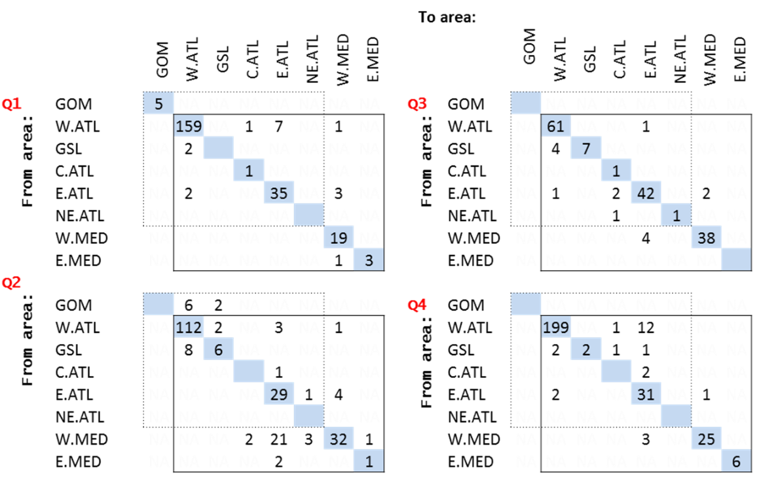

 

**Figure 1.**  The 8-area spatial definitions of the 2015 ICCAT bluefin tuna data preparatory meeting (ICCAT 2015, left) and the 11-area spatial definitions of the latest electronic tagging disaggregation (Lauretta. pers. comm., right).

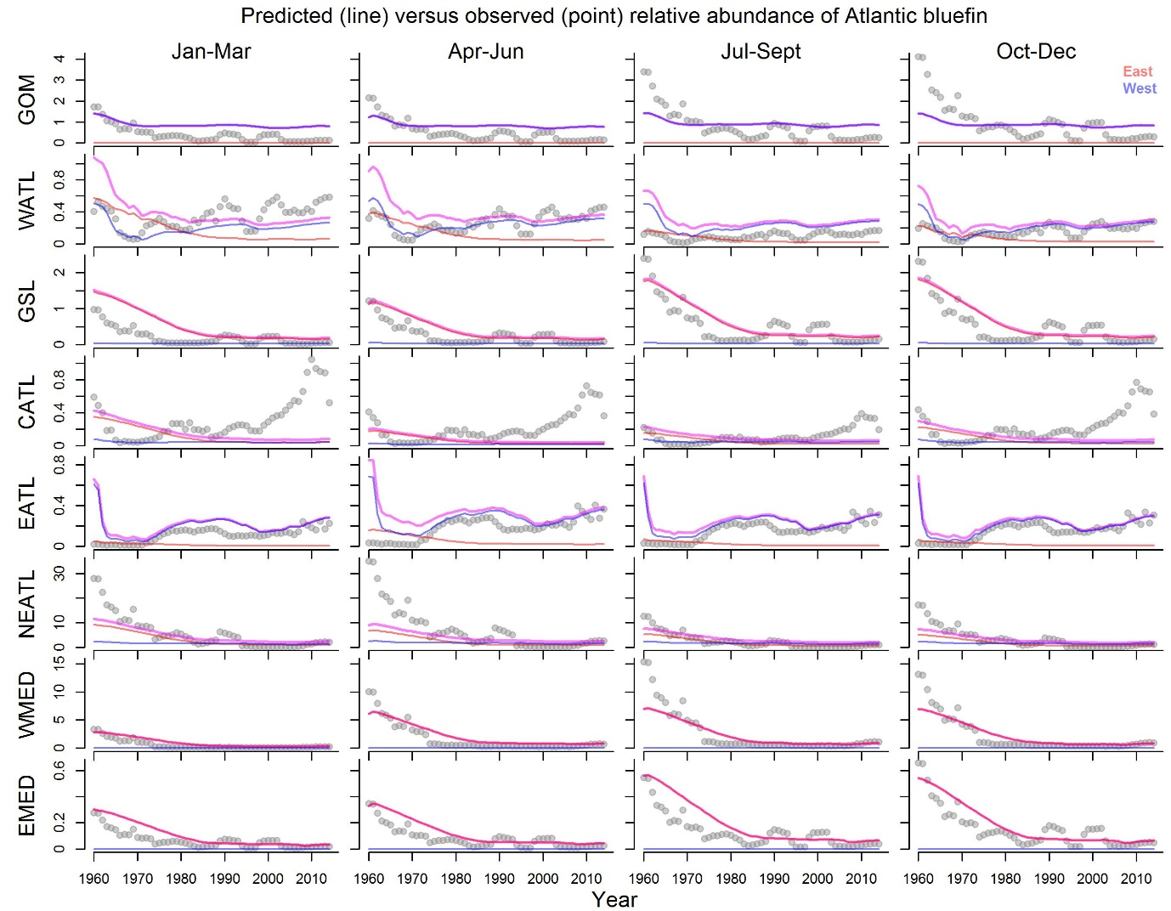

**Figure 2.** The observed versus predicted master relative abundance index (note that the y-axis is rescaled among rows). The relative abundance trends of the Eastern and Westerns stocks are represented by the red and blue lines respectively. The violet line represents the relative abundance the stocks combined.

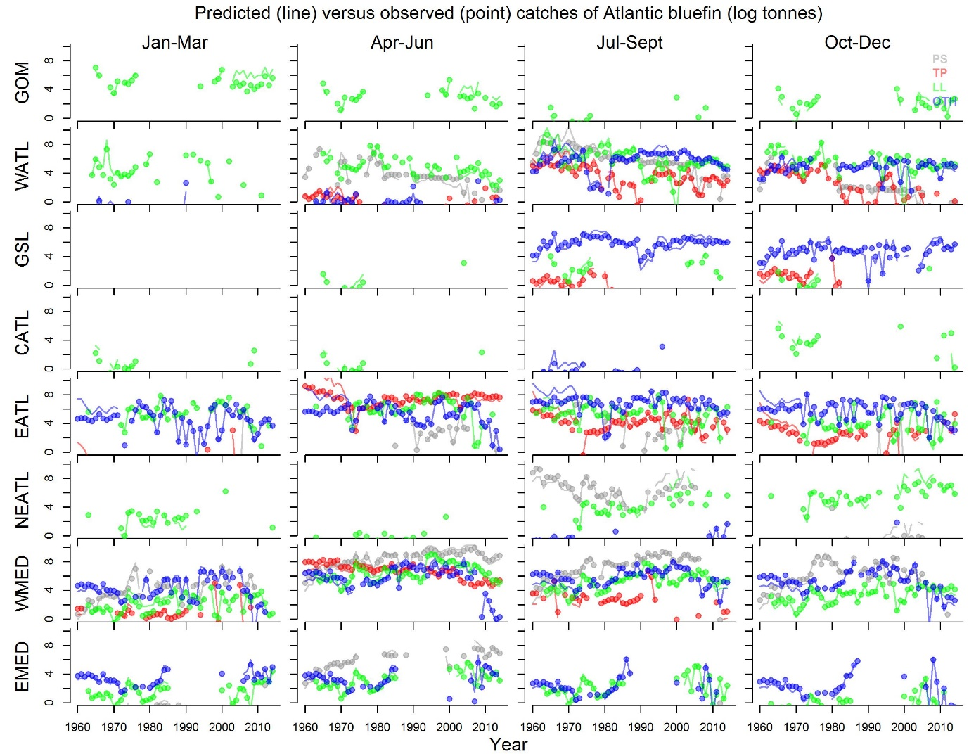

**Figure 3.** Model predicted (lines) versus observed (points) log catches of Atlantic bluefin tuna.

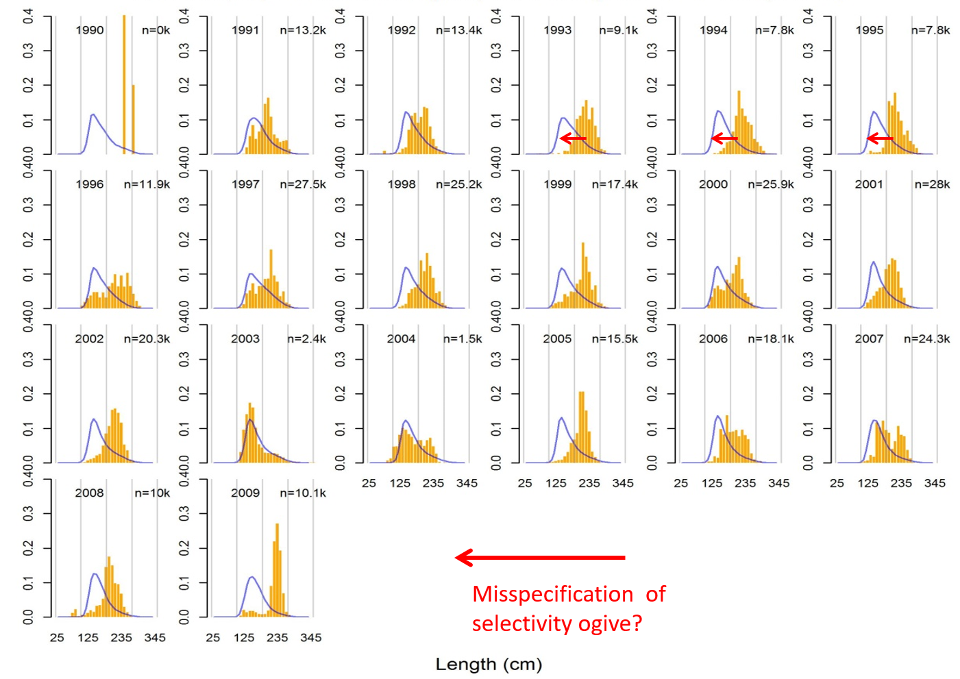

**Figure 4.** Model predicted (blue line) versus observed (orange bars) length composition data for the trap fleet type (TP: all trap gear group code fisheries from 1990 – 2009). The numbers in the top right hand corner of each panel are the number of observations.

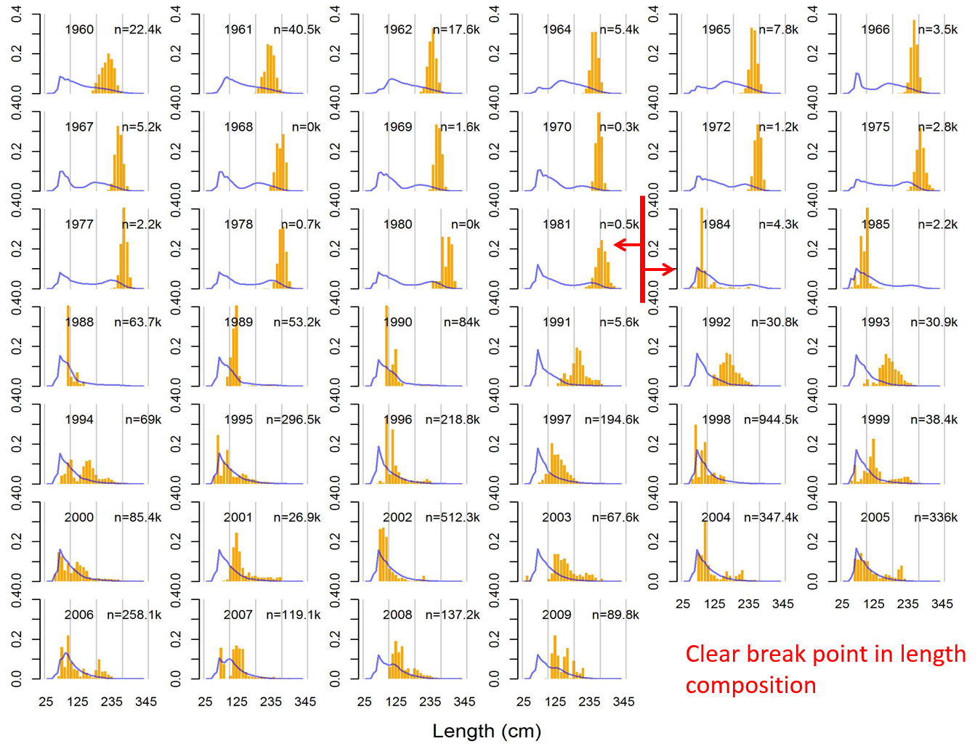

**Figure 5.** Model predicted (blue line) versus observed (orange bars) length composition data for the purse seine fleet type (PS: all purse seine gear group code fisheries from 1960 – 2009). The numbers in the top right hand corner of each panel are the number of observations.

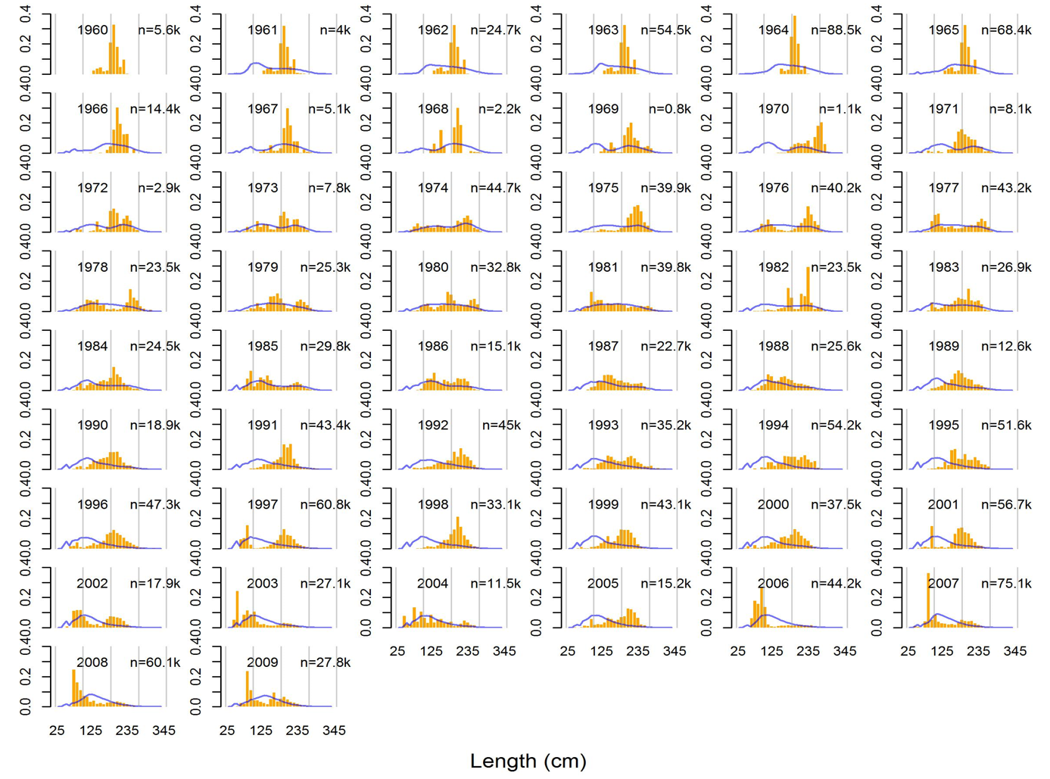

**Figure 6.** Model predicted (blue line) versus observed (orange bars) length composition data for the longline fleet type (LL: all purse seine gear group code fisheries from 1960 – 2009). The numbers in the top right hand corner of each panel are the number of observations.

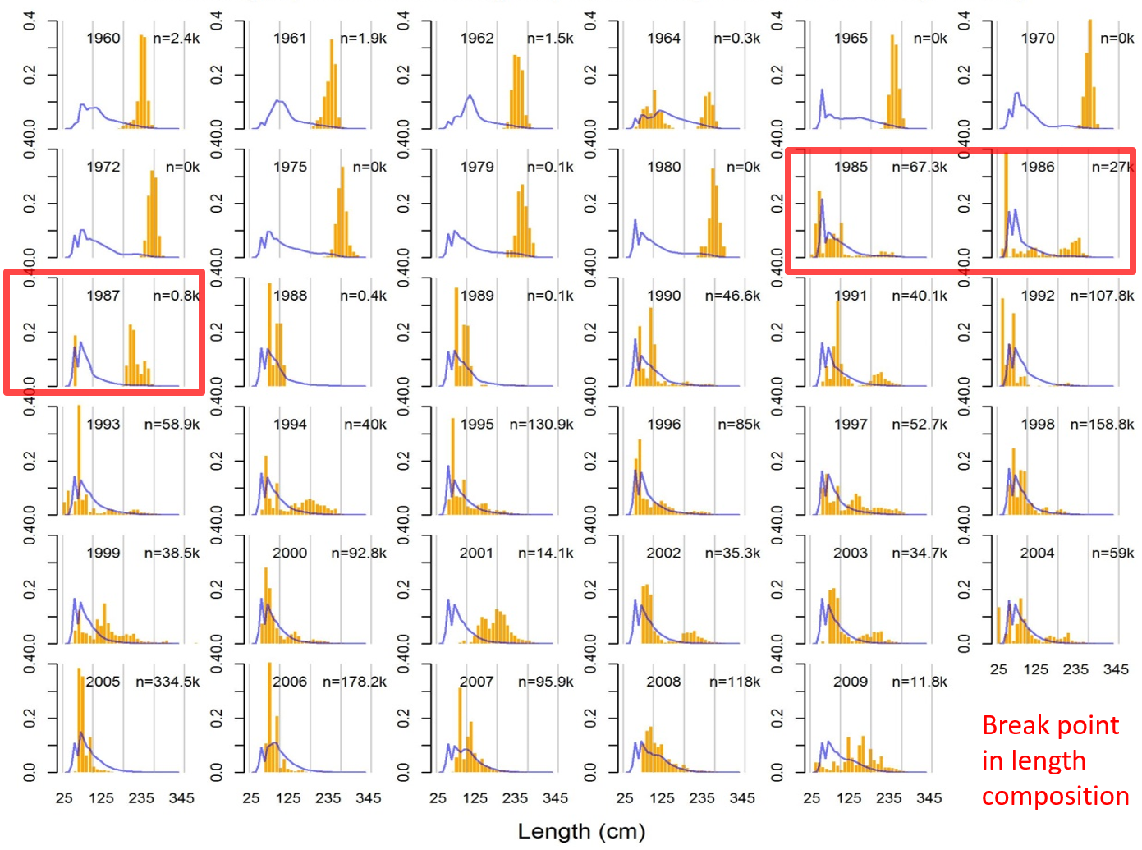

**Figure 7.** Model predicted (blue line) versus observed (orange bars) length composition data for the other fleet type (OTH: all non-trap, non-purse seine, non-longline gear group code fisheries from 1960 – 2009). The numbers in the top right hand corner of each panel are the number of observations.

1. IOF, 2202 Main Mall, University of British Columbia, Vancouver, B.C., Canada, V6T 1Z4. t.carruthers@fisheries.ubc.ca